Part 1
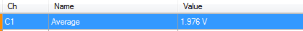
Resistances = 4k and 6k

Part 2

Resistance | Measured voltage
604 | 4.96
4k | 3.748
20k | 2.744
60k | 2.538
249k | 2.5026

Part 3

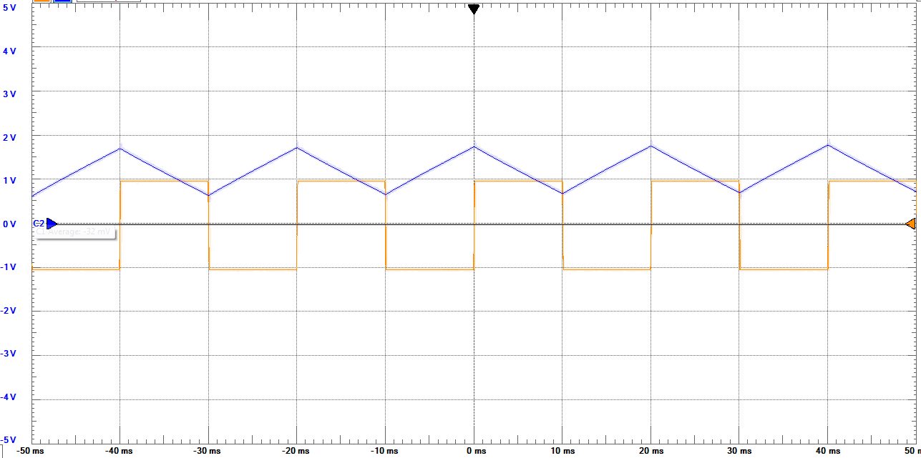
...also exported

Part 4

Measured voltage from green to black: 0.512V

